**CS396 Software Design Principles and Practices**

**Project: Milestone 1 Report**

# **People**

Evelyn Hung

# **Option**

3

# **Link to Project GitHub Repository**

<https://github.com/nu-cs-sw-design/project-20252601-396_final.git>

# **Project Planning**

(Instruction: Please break down the activities needed to complete this project and a timeline.)

# **Initial Analysis**

# ***For Option 3: Refactor a Given Messy Project***

The class diagram of the current design:

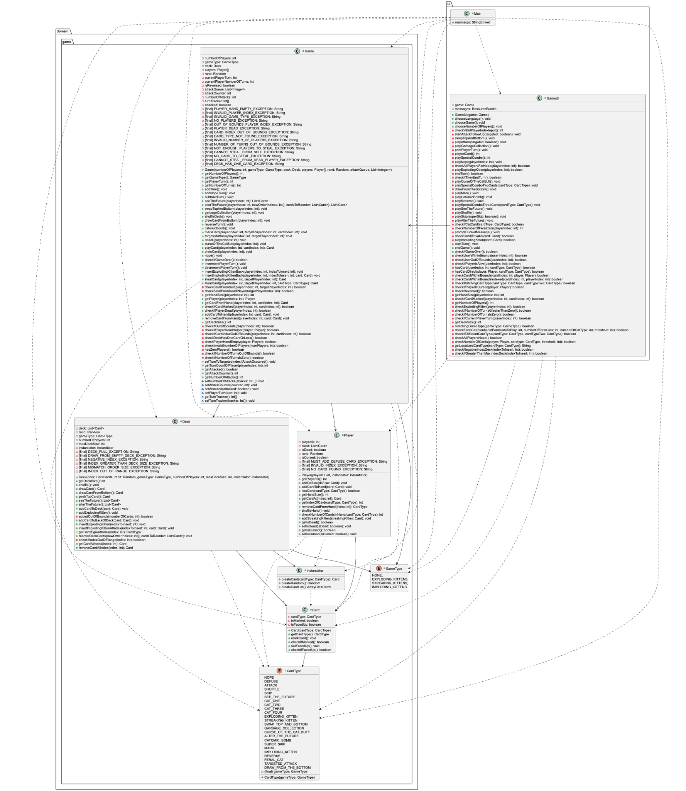

Use cases:

* Starting game
* Playing the exploding kitten card
* Playing the Nope card
* Playing the Shuffle card
* Playing the